Integrated Energy Therapy®  Integrated Energy Therapy, developed at the Center of Being, by Stevan J. Thayer, is the next level to heal with the energy of angels. IET uses a divine angelic energy ray to work directly with your 12-Strand Spiritual DNA. IET supports you in safely and gently releasing limiting energy patterns of your past, empowering and balancing your life in the present, and helps you to reach for the stars as you evolve into your future.  Benefits of IET  Painlessly identifies and releases your deeply suppressed feelings and your core cellular memories.  Clears energy blocks that limit your health, life purpose, prosperity and creativity.  Empowers you to experience fulfilling loving relationships in all areas of your life.  Helps you to discover and live your Soul’s mission in life.  Provides gentle yet powerful support for survivors of childhood traumas such as physical and sexual abuse, alcoholic and dysfunctional families.  Supports your self-healing at all levels, physical, emotional, mental and spiritual.  Increases your connection to your angels and helps you work with them in your life.  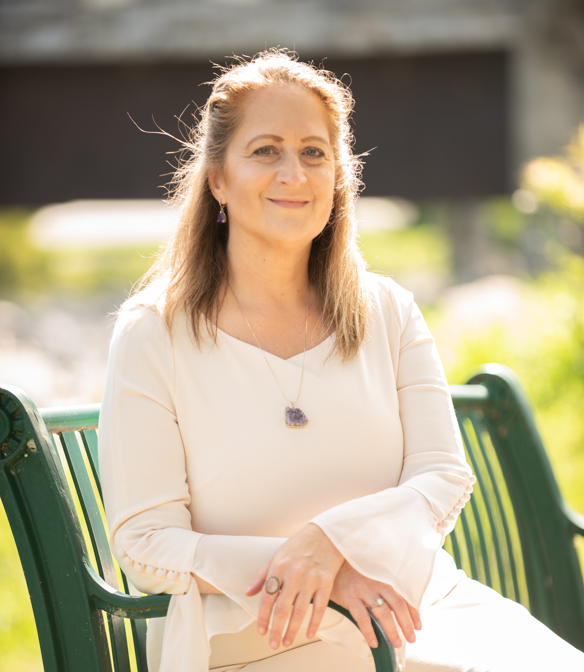  Melissa L Watkins  Melissa L Watkins is the founder of melissaLwatkins.com website that features her blog and services. Also, her Facebook following at Melissa L Watkins: Guidance 311, where she provides inspiration and methods to help develop skills to utilize the Law of Attraction in your own life. She is a Medium that specializes in teaching you how to connect to your own spiritual gifts, doing the Shadow Work involved in developing those spiritual gifts, and providing opportunities to work directly with her for connection to loved ones or guidance on your path. Melissa’s passion is for teaching spiritual development and mediumship courses. She has become Reiki Level 1 and Master Instructor, IET. | 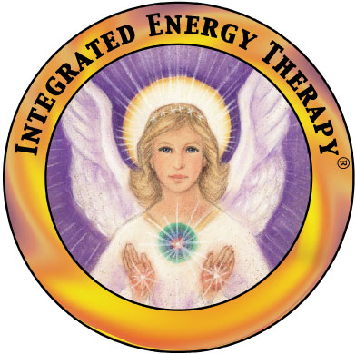  IET Sessions  We start the session by discussing which areas of healing you wish to focus on. During the IET session, you lie fully clothed and relaxed on a massage table while soft soothing music is played in the background. Next, IET energy is systematically directed into specific areas of your body's cellular memory by means of gentle therapeutic touch, and powerful IET techniques are used to gently get your issues out of your tissues for good.  Your first IET sessions will likely be focused on using the Basic and Intermediate IET ray to clear the limitations and pain from your past. As the pain from your past clears, we will use the Advanced IET ray to help you manifest your life’s vision and bring your dreams alive.  At the end of an IET session, it is typical to feel relaxed, recharged and refreshed. | A Complementary Holistic Therapy  Integrated Energy Therapy is complementary to other healing arts and can be used alone or in combination with other holistic or traditional approaches to accelerate your self-healing journey. However, IET is not a replacement for traditional medical approaches.  Please note that while IET can be very effective, no medical claims are made as to the effect or outcome of this treatment approach. Each person is encouraged to be responsible in the use and choice of professional healing assistance as needed.  Fee  $190 Individual Session  $470 Package (3 Sessions)  IET Training Classes  Integrated Energy Therapy is fun and easy to learn. It is a powerful self-healing technique and can be used to facilitate the treatment of clients. IET can be used as a stand-alone therapy technique or incorporated as a powerful addition to other techniques such as Reiki and Therapeutic Massage. Melissa L Watkins teaches the Basic, Intermediate and Advanced levels of IET. Please ask about our current teaching schedule.  Healing with the Energy of Angels  through  INTEGRATED  Energy Therapy®  Melissa L Watkins  Auburn NY  315-283-7095  guidance311.com

